11
Digital Signature
COMPUTER SCIENCE

Objectives

- DS provide security against the baneful influence exerted by strangers.

Applications
- E-mails
- E-commerce
- forces

Introduction
REQUIRMENT OF DIGITAL SIGNATURE:

- Signature, a bit pattern. depends on message

- signature use information unique to sender

- easy to produce

- easy to recognize and verify the digital signature

- It must be infeasible to forge a digital signature

- It must be practical to retain a copy of digital signature

definition

- A mechanism that enables the creator of a message to attach a code that acts as a signature.

- The signature is formed by taking the hash code of the message and encrypting the message with creator’s private key.

why we need ds

- The signature guarantees the source and integrity of the message.

- Must verify author and date and time of signature.

- Must to authenticate the contents at the time of signature.

- Must be verifiable by third parties, to resolve disputes.

Details Panel

BENEFITS

- Electronic equivalent of signed paper forms

- Enables business processes that are:

- More convenient
- Faster
- More efficient Easy to implement in
- existing application infrastructure

- Store the transaction with its signature for later verification and proof

- Strongest of the electronic signatures

DIGITAL SIGNATURE STANDARD

- DSS makes use of the secure hash algorithm.

The DSS was
- Proposed in 1991
- Revised 1993, 1996
- In 2000 an expanded version of standard was issued.

This latest version incorporates digital signature algorithm based on RSA.

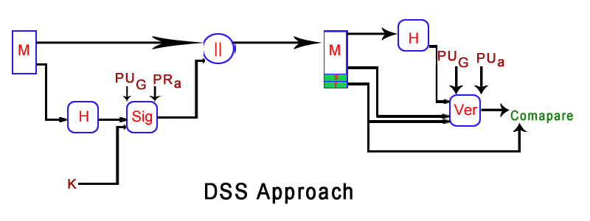

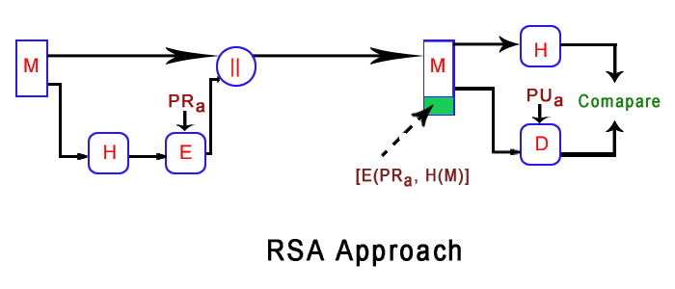
AUTHENTICATION PROTOCOL

1. MUTUAL AUTHENTICATION:

Authentication protocol satisfies both parties.

Symmetric encryption approach
- KDC is responsible for distributing session keys
- Two parties share their secret or master keys with KDC and add a time stamp.

Public Key encryption approach
- AS (authentication server): provides public key certificate.
- Not responsible for distributing session.

2. ONE WAY AUTHENTICATION:

Technique for e-mail encryption

Symmetric encryption approach
- Sender issue a request to the intended recipient
- Await a response includes a session key
- Send message

Public-key encryption approach
- One-time secret key encrypt
- ‘A’ encrypt one-time key with ‘B’ public key
- Then use that key to decrypt the message.

This scheme is more efficient than simply encrypting the entire message with B’s public key

References
Design Team

CRYPTOGRAPHY AND NETWORK SECURITY

WILLIAM STALLING

EDITION 4

RAFIA ALEEM

ALIYA ALI

ANUM AFAQ

TAHIR MALIK


